- Write a Java program to insert 10, 20, 30 ....in an array and display them.
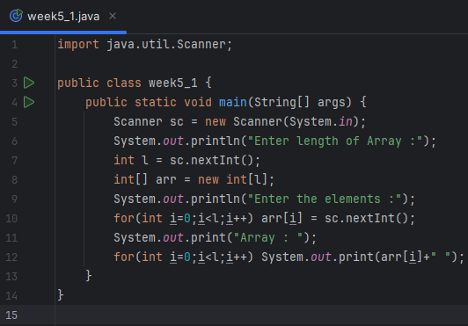
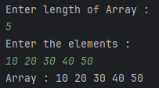
- Write a Java program to calculate the sum of all the array elements.
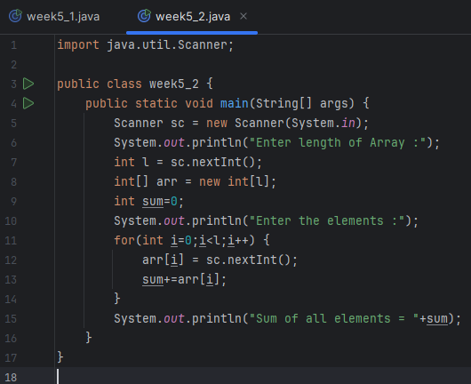
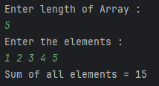
- Write a java program to print the following pattern:
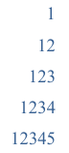
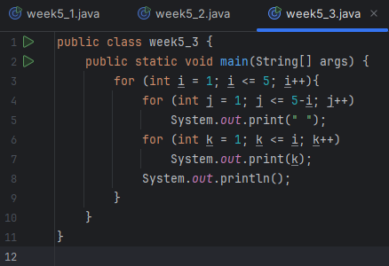
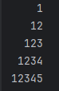
- Write a java program to find the sum of following series where n is input by the user:
1+1/2+1/3+1/4+...............+1/n
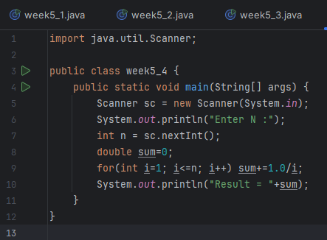
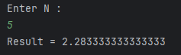
- Write a Java program and compute the sum of the digits of an integer.
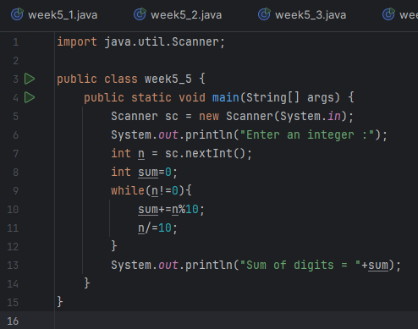
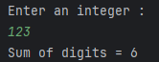
- Write a Java program to calculate the factorial of a number.
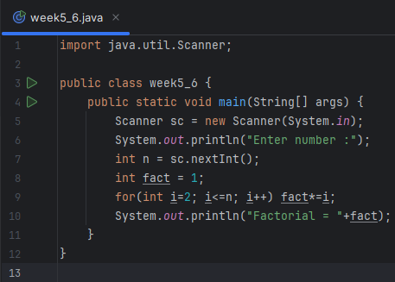
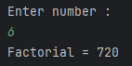
- Write a Java program to find the largest element in a given integer array.
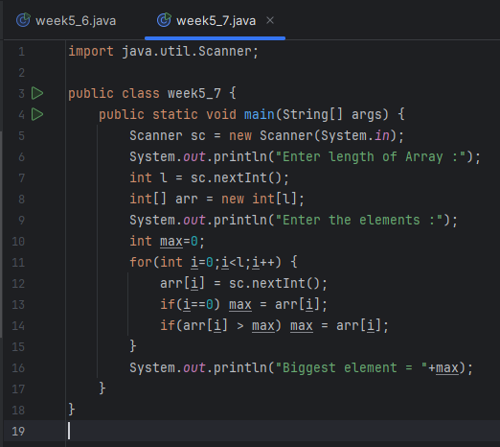
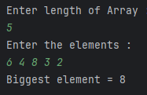
- Write a Java program to reverse the digits of a given integer.
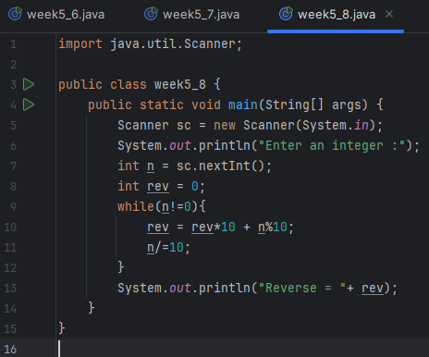
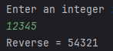

- Write a Java program to check if a given number is a palindrome or not.
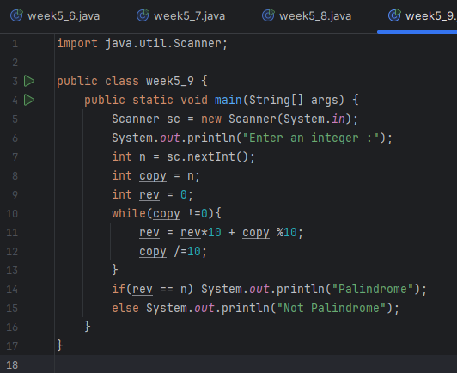
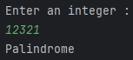

- Write a Java program to convert a decimal number into Hexadecimal number and vice-versa.
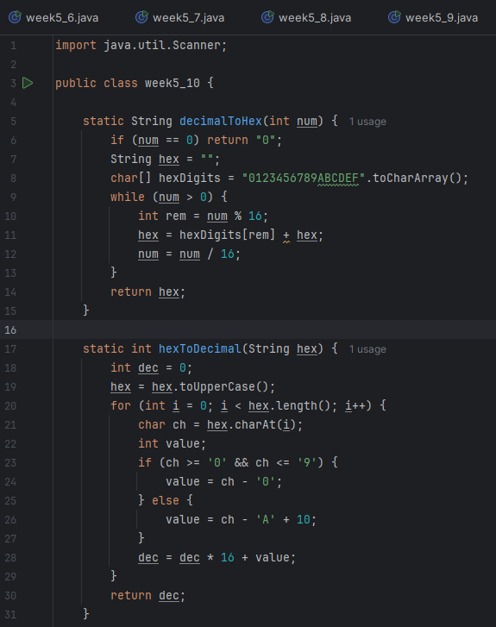
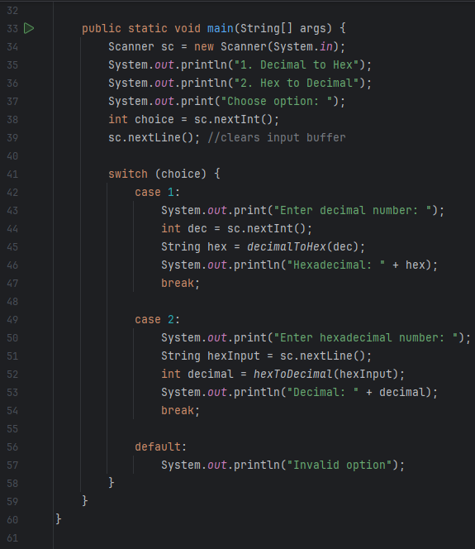
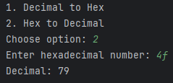

- Write a Java program to print the following pattern:
